Check what roles the user already has, remove them all if required (except system user)

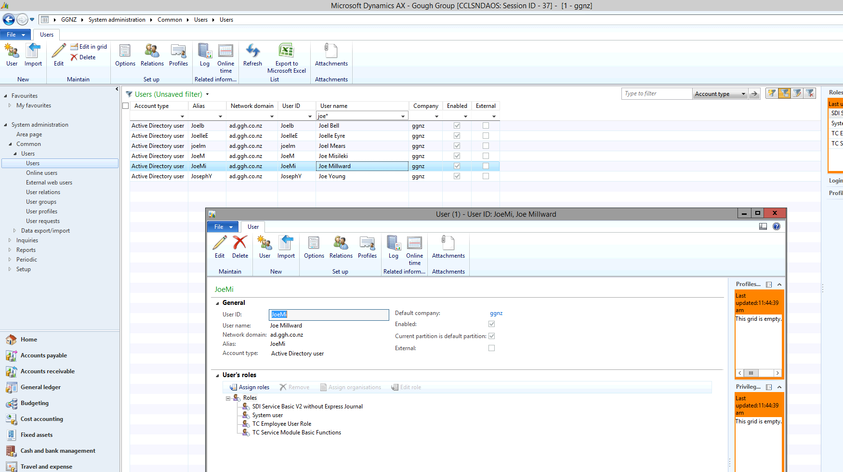

Navigate to: \\ad.ggh.co.nz\resources$\NAXT\SOD\Role XPO's\Ready For Prod\Prod User Role Profiles

Open appropriate excel file relating to similar user

Find similar user and their roles

Copy roles

Create a new CSV file

Paste roles

Add a second column and put the user’s alias

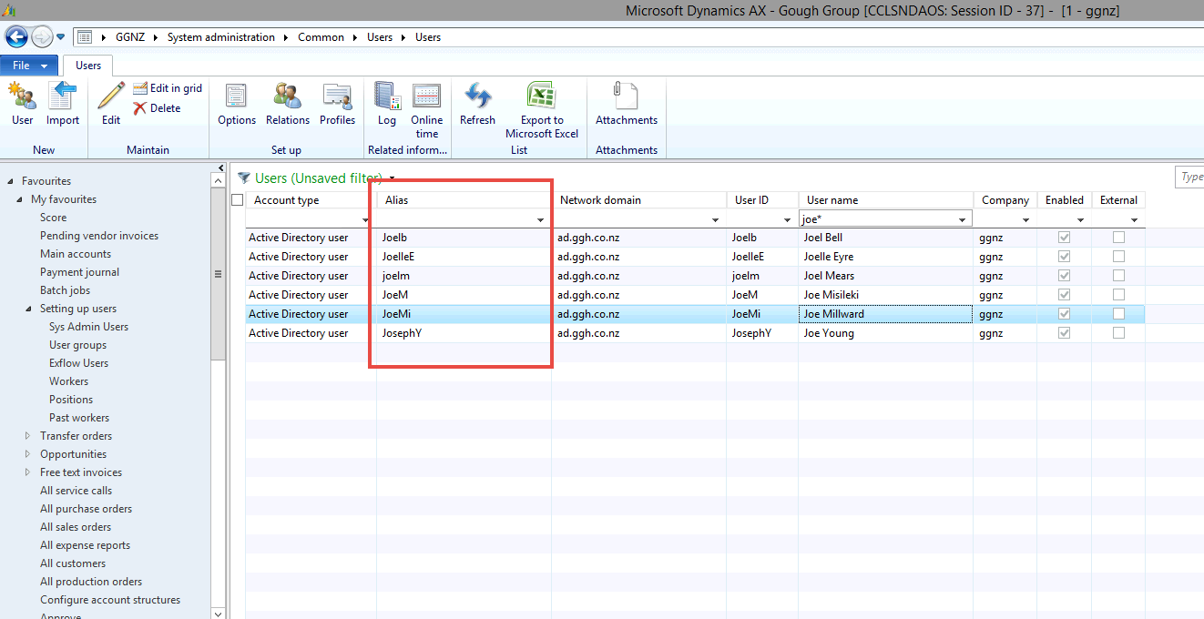

Add a third column and add GGNZ next to each line

Copy all data

Paste data on last line underneath first lot of data

Change the third column for that second data to DAT

Should look something like this

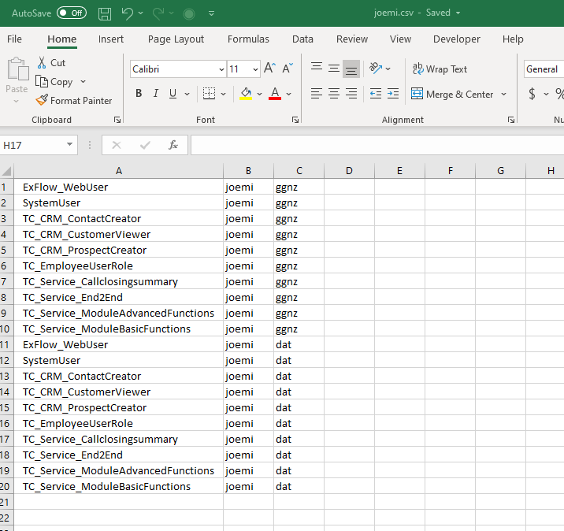

Save CSV file somewhere

Open AOT table (CTRL D) in NAXT

Find SDI_SetUserRoles_V2(usr)

Right click > open

Locate that CSV file > OK

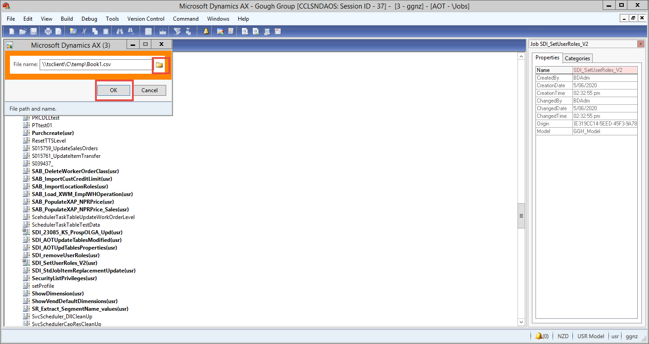

Roles should now be loaded

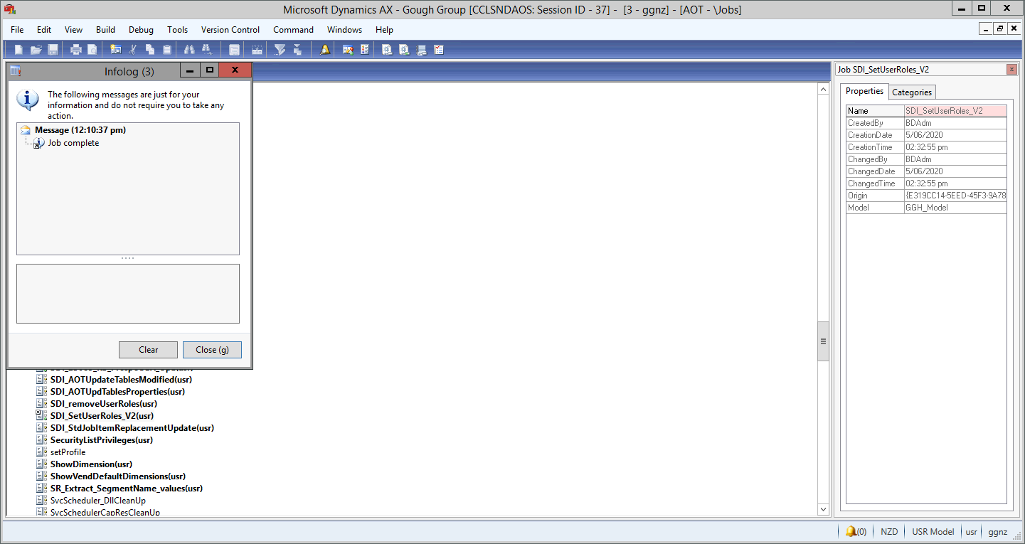

Check user to double check